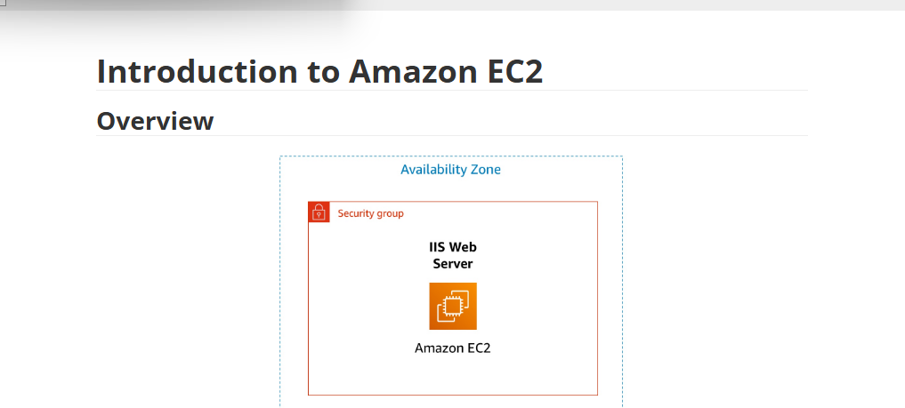
✅ Tasks
  - 🖥️ Launching EC2 Instance
    - Created a new EC2 instance named Web Server.
    - Chose Windows and t3.micro instance type.
  - 📊 Monitor Your Instance
    - Checked CPU usage and system status in the EC2 Monitoring tab to confirm the instance was running correctly.
  - 🔒 Update Security Group and Access the Web Server
    - Added an inbound rule for HTTP (port 80) from anywhere to allow access to the web server.
  - 🔄 Resize Instance and EBS Volume
    - Stopped the instance.
    - Changed the instance type to t3.micro.
    - Increased EBS volume from 8 GB to 10 GB.
  - 🛡️ Test Termination Protection
    - Enabled termination protection.
    - Tried to terminate the instance and confirmed AWS blocked the action until termination protection was disabled.
⚡ Challenges
  - No challenges faced; the lab was straightforward.
💡 Takeaways
  - ✅ Ensure security group inbound rules are correctly configured for required access.
  - 🛡️ Enable termination protection to prevent

The First phase of Completing an Ec2 instance Starts in the Lab….
Click-“Start Lab”…(this environment is essentially for demonstration of creating a real life EC2 instance
Step1: ON the far top left AWS tab with a colour button is visible. Initially being red> .then > yellow.. when its green you may begin the Lab..
The same tab activates the AWS Management Console, it opens in the next Tab.
(AWS Management Concole)
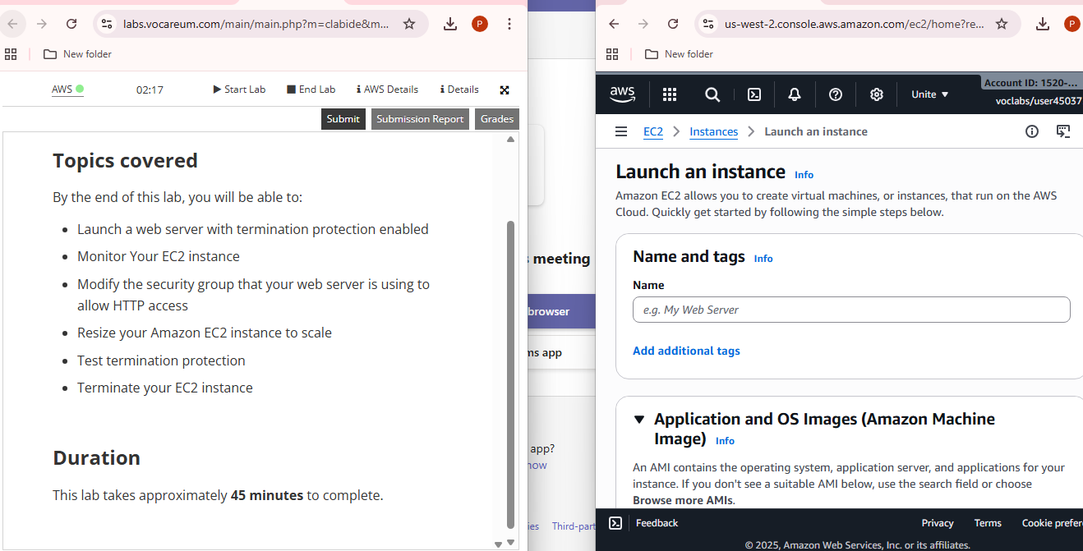
The instructions above (left side) are practised in the Management console on the far (right)
Which opened in another tab.
- Search EC2….”Open”….>Launch instance
- Under “Name and tags”…..we named the instance “Web Server”…for Practise purposes.
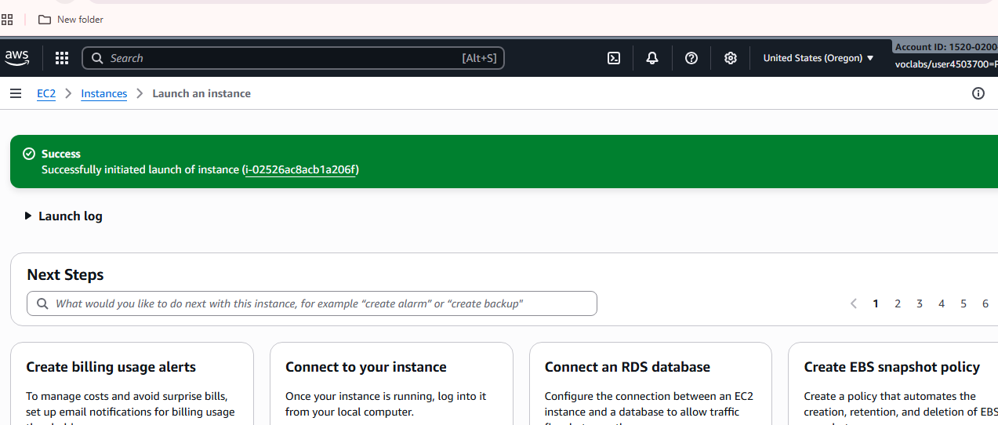

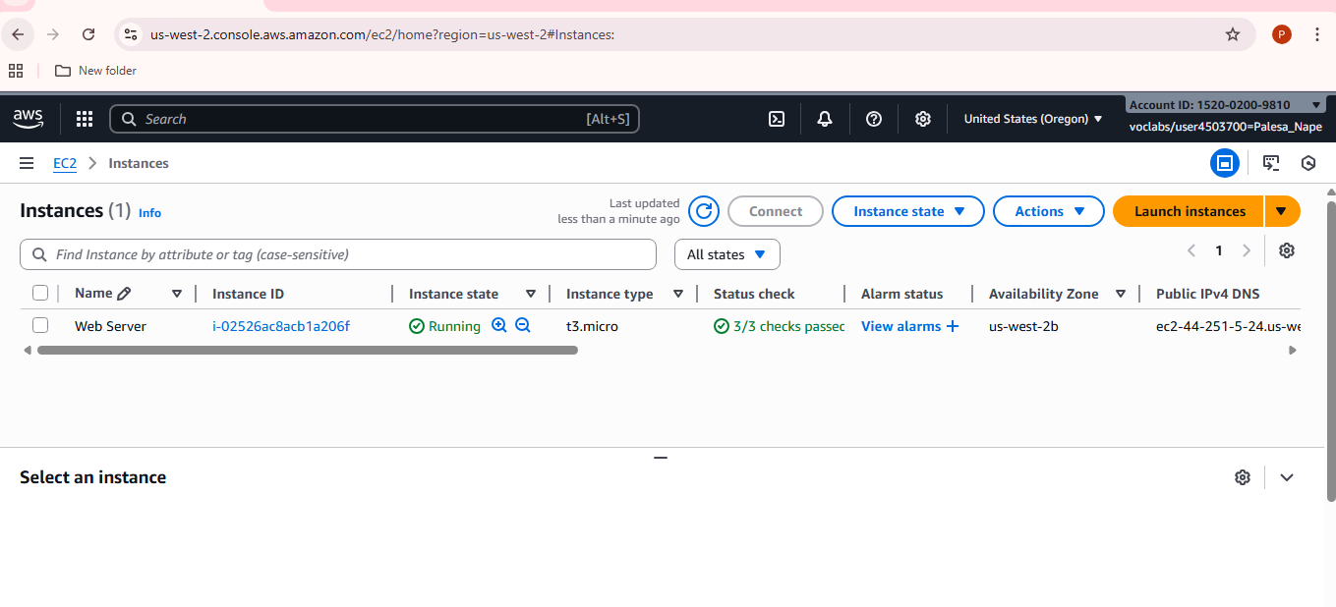
This above image is your next screen after you have launched the instance. When all stages are complete and successful…you have a 1/1…or 2/2 or 3/3….depending on the type of instance .
To view your successful running instance and geta screenshot.
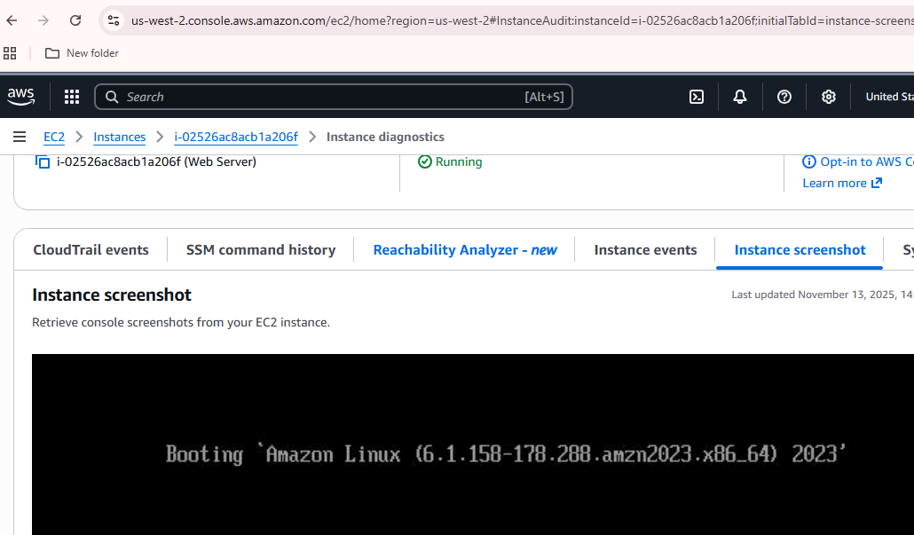

The Instance can also be stopped, By terminating the running instance on the Instances Tab,
Further it can also be re started. And Re launched.
